Task 2: Assets Gatheing
Student Name: Saim Fareed
Registration Number: LL-000022787

Assets Log:
Asset Name | Source/URL | Description | Purpose | Date Retrieved | Licence Type
Hero background image | Pexels (pexels.com) | Photo of fresh vegetables at a farm market | Homepage hero section to show local produce | 23/04/2026 | Pexels Free License
Organic Mixed Salad Leaves image  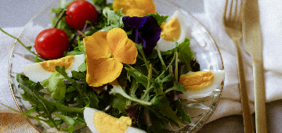 | Pexels | Photo of mixed green salad leaves | Product image on Products page | 23/04/2026 | Pexels Free License
Heritage Tomatoes image  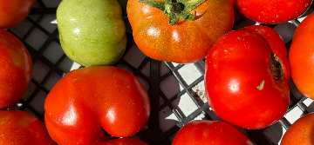 | Pexels | Photo of red and yellow heirloom tomatoes | Product image on Products page | 23/04/2026 | Pexels Free License
Sourdough Loaf image  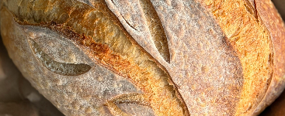 | Pexels | Photo of artisan sourdough bread | Product image on Products page | 23/04/2026 | Pexels Free License
Free Range Eggs image  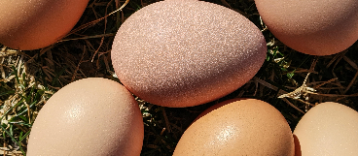 | Pexels | Photo of brown eggs in a cardboard carton | Product image on Products page | 23/04/2026 | Pexels Free License
Raw Cow Milk Cheese image  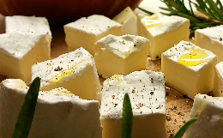 | Pexels | Photo of a whole cheese wheel | Product image on Products page | 23/04/2026 | Pexels Free License
Artisan Butter image  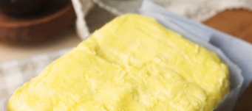 | Pexels | Photo of butter wrapped in parchment paper | Product image on Products page | 23/04/2026 | Pexels Free License
Honey Jar image  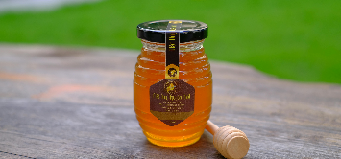 | Pexels | Photo of honey jar with a dipper stick | Product image on Products page | 23/04/2026 | Pexels Free License
Organic Carrots image  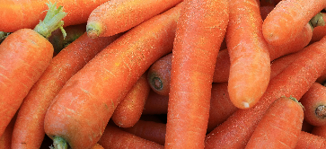 | Pexels | Photo of fresh carrots with green tops | Product image on Products page | 23/04/2026 | Pexels Free License
Apple Cider Vinegar image  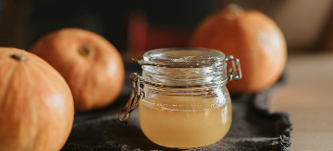 | Pexels | Photo of vinegar bottle with apples | Product image on Products page | 23/04/2026 | Pexels Free License
Duck Eggs image  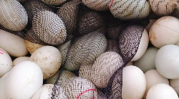 | Pexels | Photo of large white duck eggs | Product image on Products page | 23/04/2026 | Pexels Free License
Rye Sourdough image  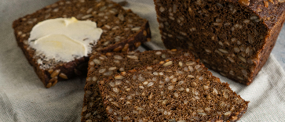 | Pexels | Photo of dark rye bread | Product image on Products page | 23/04/2026 | Pexels Free License
Leaflet CSS | Leaflet CDN (leafletjs.com) | CSS stylesheet for map display | Styling the interactive map on About page | 24/04/2026 | BSD 2-Clause License
Leaflet JavaScript | Leaflet CDN (leafletjs.com) | JavaScript library for interactive maps | Map functionality on About page | 24/04/2026 | BSD 2-Clause License
OpenStreetMap tiles | OpenStreetMap (openstreetmap.org) | Map tile images for displaying geography | Background mapping for producer locations | 24/04/2026 | Open Data Commons ODbL
Producer location data | Estimated from Greenfield area | Latitude and longitude coordinates for 4 producers | Map markers on About page | 25/04/2026 | original data
Leaflet marker icon | Custom CSS and HTML | Custom green marker with leaf emoji | Visual markers for producer locations on map | 24/04/2026 | original code

Products Images URLs:
Organic Mixed Salad Leaves: https://images.pexels.com/photos/30472978/pexels-photo-30472978.jpeg
Heritage Tomatoes: https://images.pexels.com/photos/33621806/pexels-photo-33621806.jpeg
Sourdough Loaf: https://images.pexels.com/photos/35597416/pexels-photo-35597416.jpeg
Free Range Eggs (6): https://images.pexels.com/photos/7177580/pexels-photo-7177580.png
Raw Cow Milk Cheese: https://images.pexels.com/photos/34406232/pexels-photo-34406232.jpeg
Artisan Butter: https://images.pexels.com/photos/12162627/pexels-photo-12162627.jpeg
Honey Jar: https://images.pexels.com/photos/7990478/pexels-photo-7990478.jpeg
Organic Carrots: https://images.pexels.com/photos/35810240/pexels-photo-35810240.jpeg
Apple Cider Vinegar: https://images.pexels.com/photos/5471920/pexels-photo-5471920.jpeg
Duck Eggs (6): https://images.pexels.com/photos/9664253/pexels-photo-9664253.jpeg
Rye Sourdough: https://images.pexels.com/photos/11214699/pexels-photo-11214699.jpeg

Why I Choose these assets:
Rationale for Selecting These Assets
Product Images: I used the website Pexels for all the product images because it provides high quality photos for commercial use without requiring any payment from users. Images like for the heritage tomatoes photo contains both red and yellow tomatoes to indicate the colour mix of the product, Sourdough Loaf photo features the shape and crust of the bread product, these real photos enhance the professionalism of the web design compared to using icons to represent products. It will show the customers what they are buying and will build trust as well.
Map API: I decided to use Leaflet with OpenStreetMap for the map API because both tools were suitable for the current website since they were completely free. They did not require an API key to access their services. The map API would showcase the locations of the producers to the customers and the users. The customers willl know where there food is coming from and will also promotre local producers and farmers. I used OpenStreetMap beacause it is a reputable opensource service which provides high quality maps across the globe for various application.
Custom Map Markers: To create map markers, I used a leaf emoji that matches with the brand colours of the website. also leaf emoji would be perfect since the company deals with local food.
Fallback Images: For images on the website I included a fallback function. It is important because sometimes the picture does not get loaded due to some reason. So to provide customers with better user experience incase if there is no picture available a relevant emoji will pop up instead. It will depend on what category of products the emoji represents like if the product is a vegetable then the picture will show a carrot emoji.

